Using Cryptool to encrypt and decrypt password,
Perform encryption and decryption of text by using cryptool 2
Using the cryptool 2 tool perform the following
a) Ceaser Cipher
b) Substitution Cipher
c) Playfair Cipher
Download the current versions of CrypTool 2. There are two versions of CrypTool 2, the stable
version and the nightly version. Both versions are available as an EXE installer and as a ZIP archive.
The EXE installer supports the creation of a start menu entry, of a desktop link and of an Explorer file
type. If you don't know which one to choose, you should prefer the stable version with EXE installer.
No admin rights are needed for the installation. Each installation type (EXE and ZIP) has its own
online update mechanism. For execution, a 64-bit Windows and Microsoft .NET Framework 4.7.2 or
higher are needed.
Download Stable version
The "Stable Version" is the CrypTool 2 release version
The current release version is CrypTool 2.1
Following is the link for download cryptool 2
https://www.cryptool.org/en/ct2/downloads
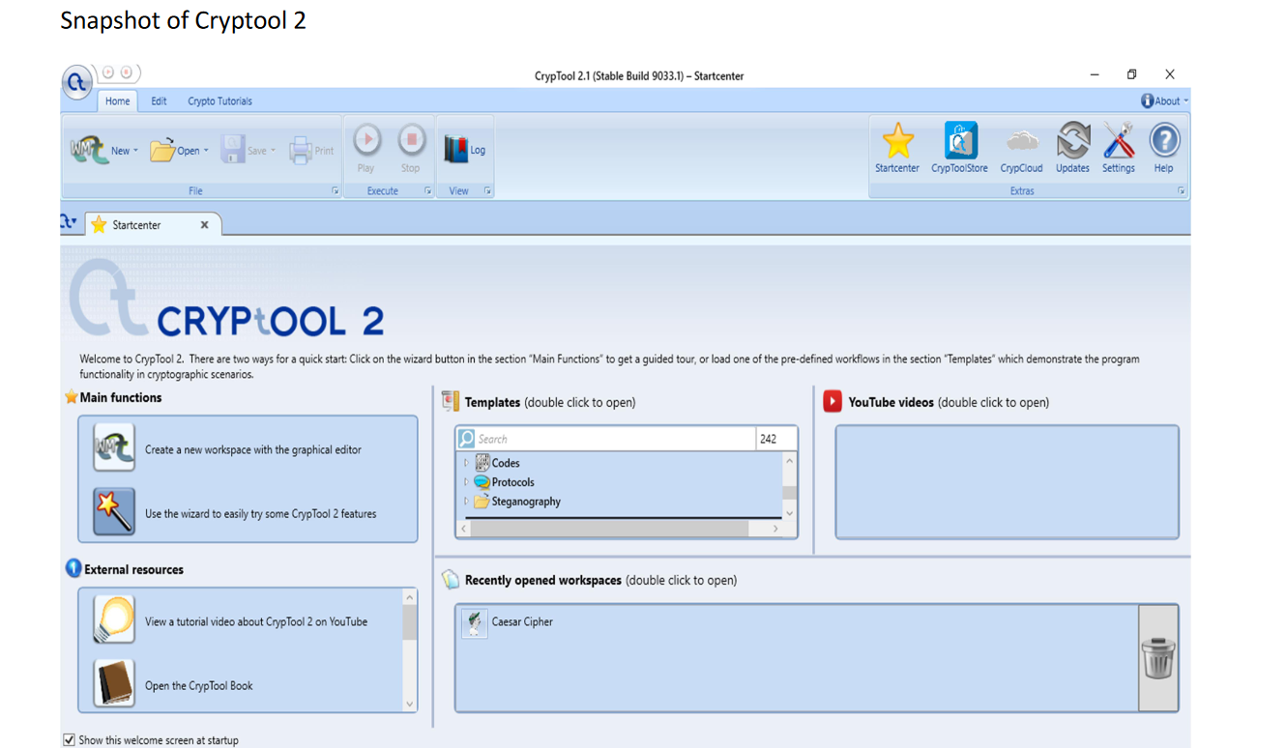
Main fuction -> Click on wizard
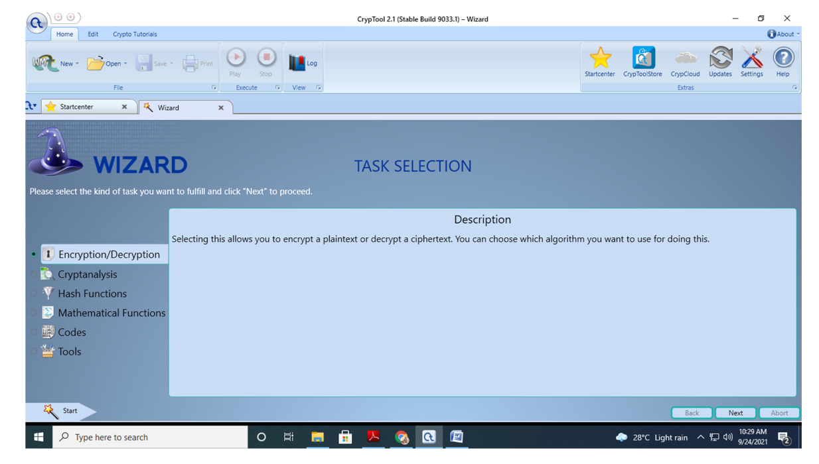
Select Task Encryption and decryption
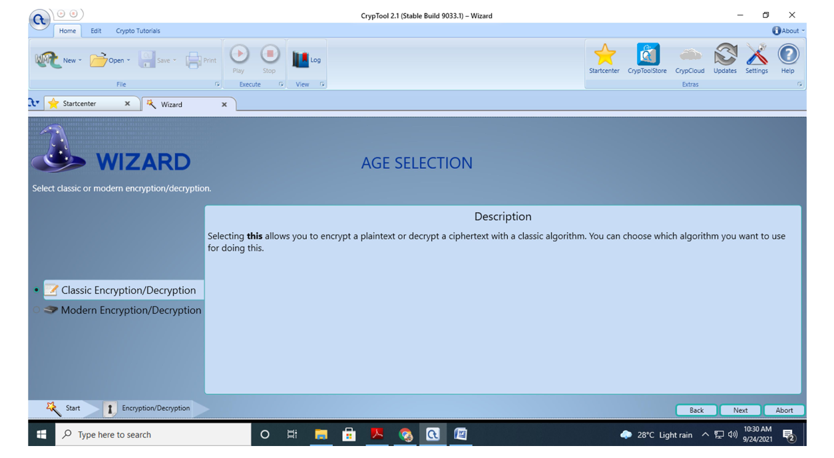
Select classic Encryption /decryption
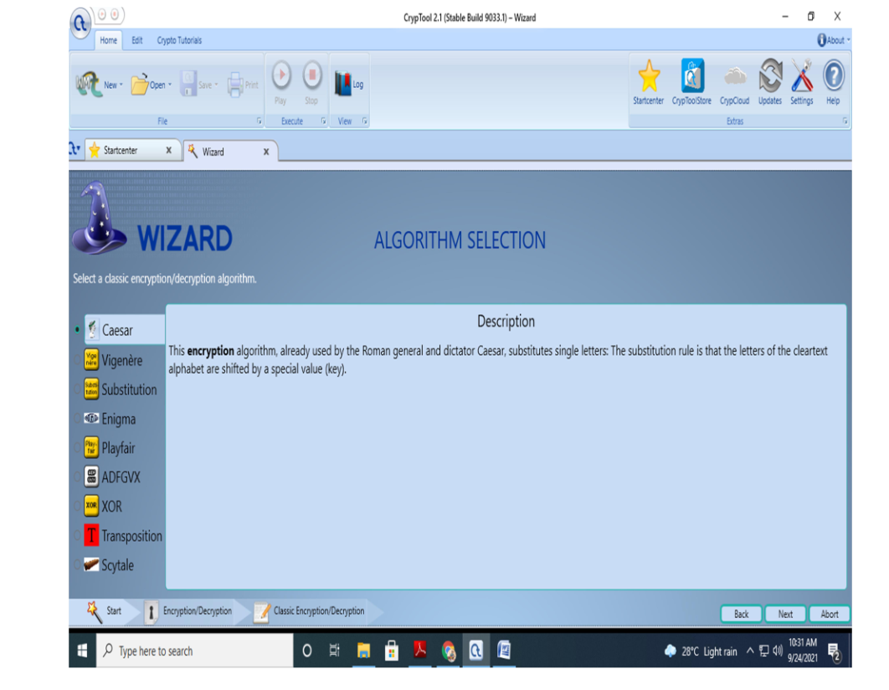
Select Caesar cipher
